World Happiness Write Up

1. What factors are most correlated to country happiness over the past 5 years in aggregate?

Single variable regression showed health (life expectancy) is most correlated with happiness followed closely by the economy (GDP) (a). Single variable regression also shows minimal correlation between happiness and the Gini Index and almost no correlation between workforce ratio and happiness. We then did basic multiple linear regression which showed that health, family and trust were all statistically significant but that the economy wasn’t. To get a deeper understanding of this we created a correlation matrix. The correlation matrix showed that our variables were very interrelated and thus the regressions we had done were likely not an accurate representation of the relationships between variables (b). To try to account for this we calculated interaction effects and included the significant ones in a new multiple linear regression. The three significant interaction effects were Gini Index:Workforce Ratio, Workforce Ratio:Economy and Workforce Ratio:Generous. This new regression resulted in a negative coefficient for economy. Because the only added variables were workforce ratio interaction effects we concluded that economy is only positively correlated with happiness when a country’s gender workforce ratio is high. The new regression also showed that health is correlated with happiness. Family, Trust and Generosity are almost statistically significant and therefore are possibly important factors.

In order based upon linear regression correlation value:

Single Variable Regression Model

* + 1. Health: 0.794
    2. Economy: 0.790
    3. Family: 0.757
    4. Freedom: 0.485
    5. Trust: -0.436
    6. Gini Index: -0.390
    7. Generosity: 0.0739
    8. Workforce ratio: 0.0736

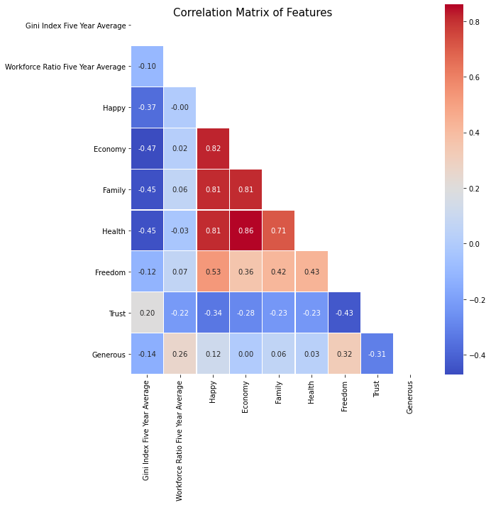

2. What factors are most dynamic over the past 5 years?

No one variable was more variable than the others. Countries with high happiness scores tended to be relatively stable across variables while countries with low happiness scores showed more variability. When countries did have significant changes in happiness, in general, all variables changed in similar ways, though the economy usually started changing 1-2 years after the other variables.

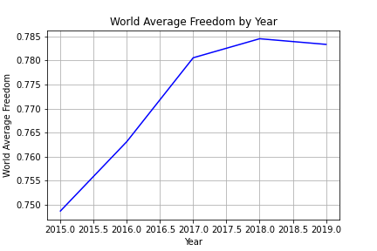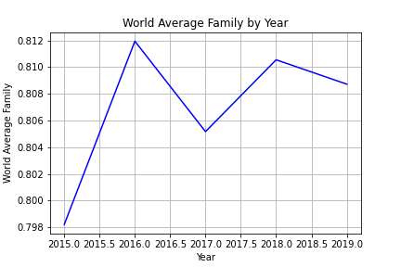

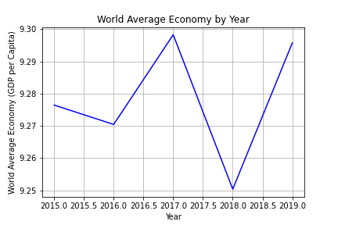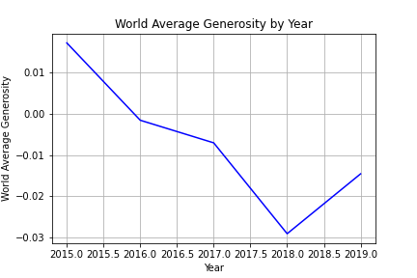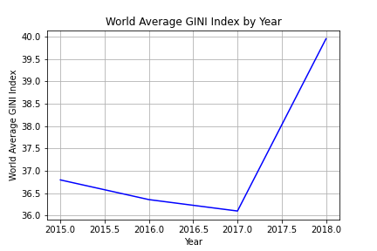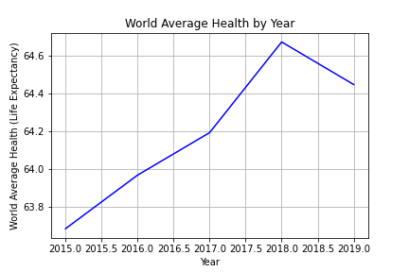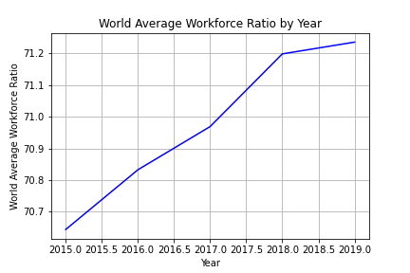

3. Identify top countries that are improving happiness/decreasing happiness? Can we hypothesize why based on our variable set?

Liberia had the greatest increase in happiness while Afghanistan had the greatest decrease. In both countries we see all variables change at the same time with the exception of the Economy which followed the same pattern but a few years later than the other variables. Both countries had major political and social change that likely caused the changes in all variables.

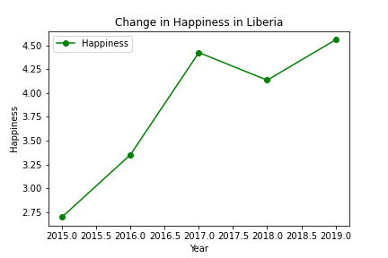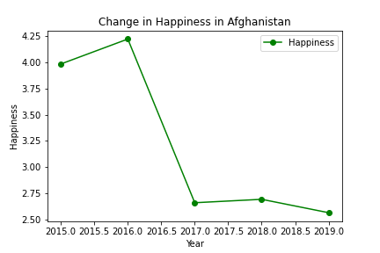

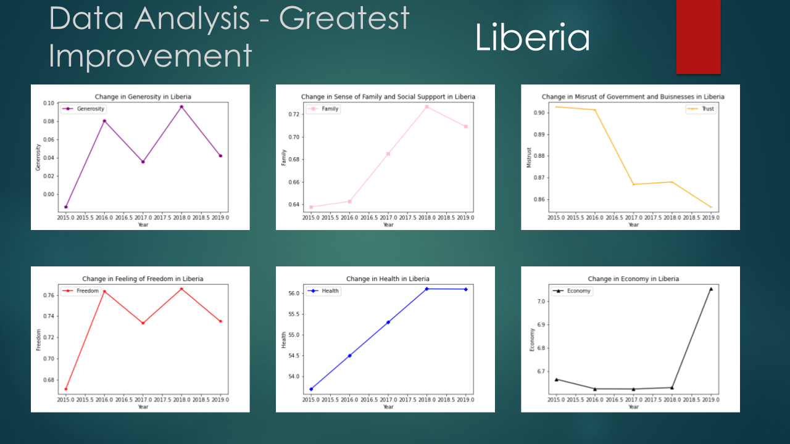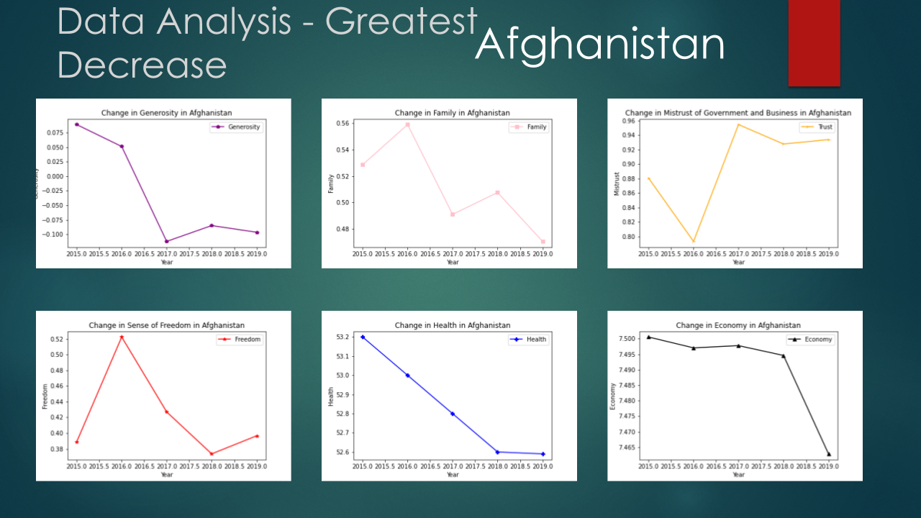

4. How do changes in factors impact country happiness over time?

Our analysis shows that, not surprisingly, happiness is a complicated thing. In large part because of how interrelated the key variables are. The clearest answer we got to this question is that gender and income inequality complicated the relationship between economy and health. A country that already has a strong GDP but high inequality can likely increase happiness by addressing that inequality. A country that has a smaller GDP should keep that relationship in mind when enacting measures to grow GDP.